**Dolphin Stranding Case Study**

**Learning Objectives**

After completing the activities, you should be able to:

* Define unusual mass stranding events
* Explain the difference between mass strandings and an unusual mass stranding event
* State one symptom of cetacean morbillivirus and explain in general how the virus is spread
* Explain in general how a virus can spread through a population of organisms
* Explain in general how a vaccine works
* State two different ways a vaccine can be created

**Introduction**

In July 2013, stranding teams (such as the Virginia Aquarium’s Stranding Response team) from New York to North Carolina started noticing a large amount of dolphin strandings.

Some data that was collected on how many dolphins were being found dead or dying on the beaches:

* 430 from July to September
* 553 total from July to November
* 6 in one day in Virginia Beach

Using your computer and the Internet, research dolphin strandings. Here is one website to get you started: [NOAA Strandings](http://www.nmfs.noaa.gov/strandings.htm). Answer the questions below based on your research. Please put your answers in your own words. **Copying directly from a website is considered plagiarism.**

1. Give two examples of marine mammals that can strand themselves.
2. Give two specific reasons why marine mammals strand themselves.

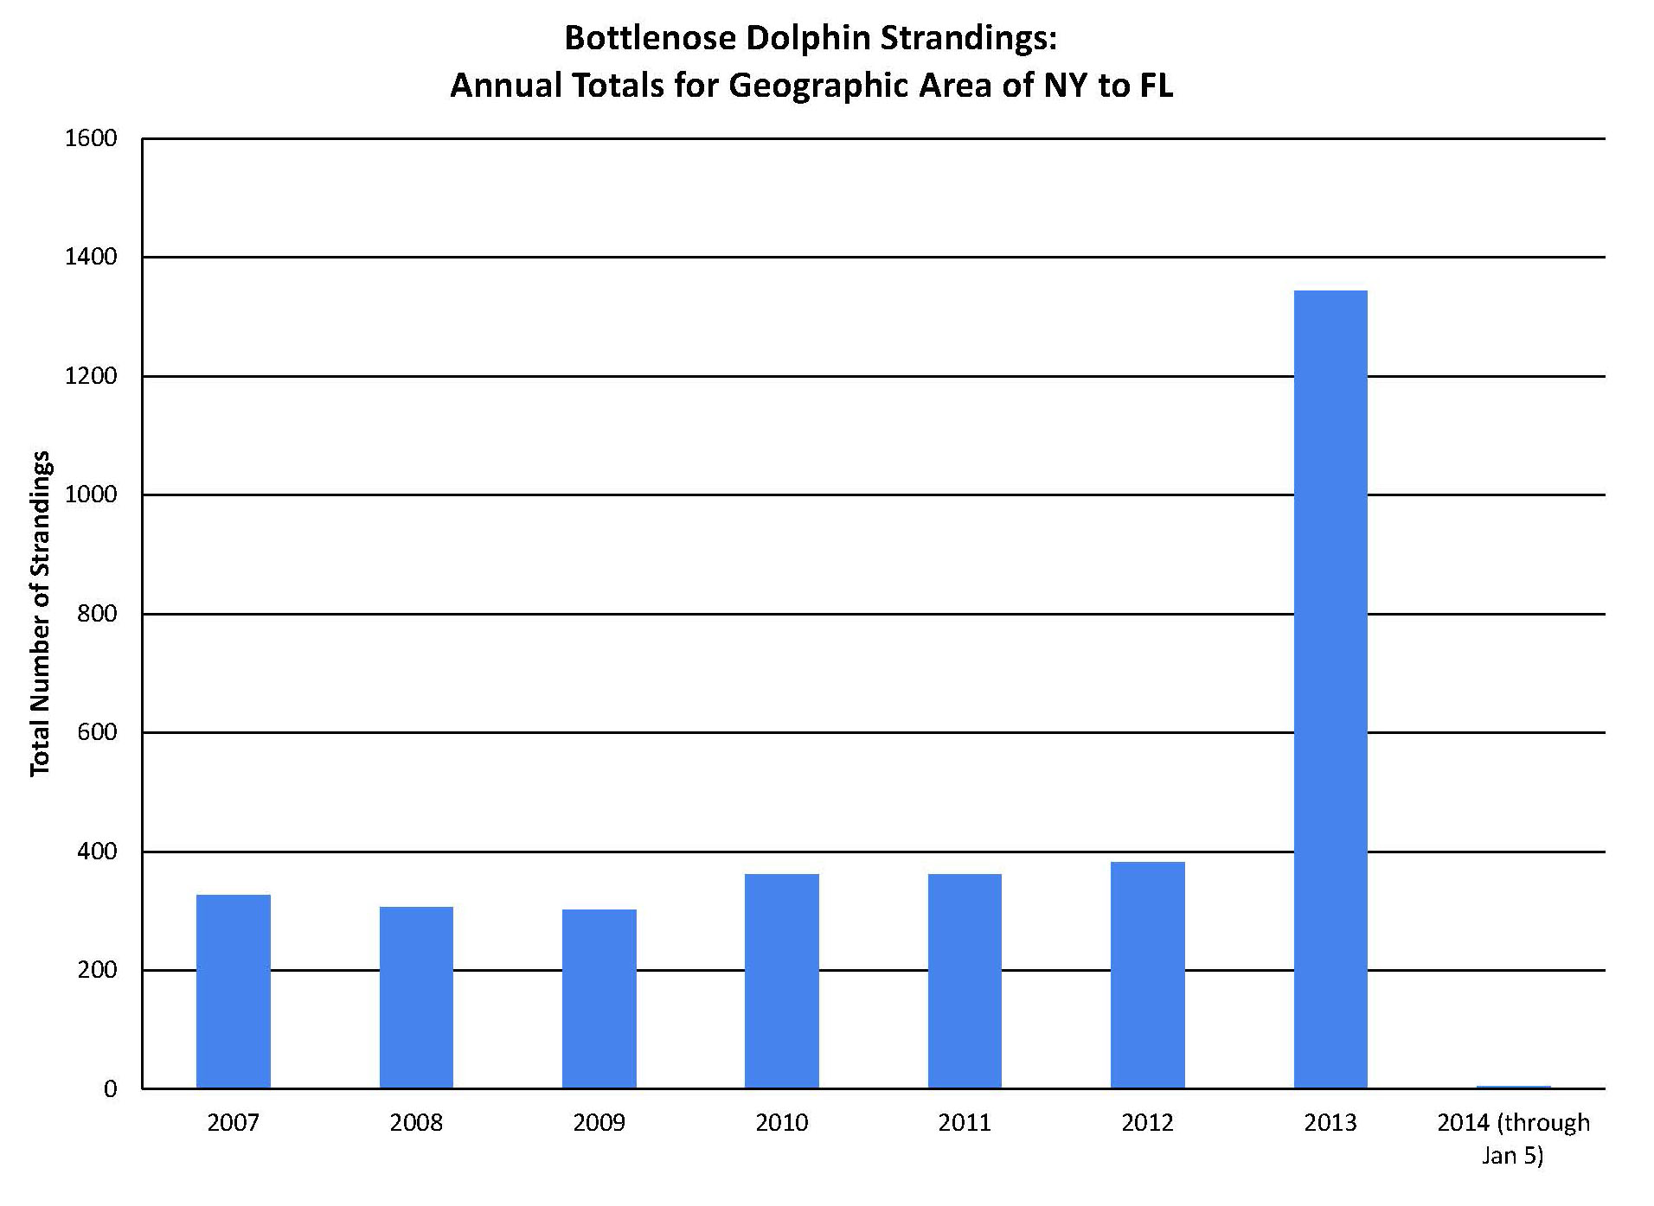

|  |  |  |  |  |  |  |  |  |  |  |
| --- | --- | --- | --- | --- | --- | --- | --- | --- | --- | --- |
| **Bottlenose Dolphin Strandings by State** | | | | | | | | | | |
|  | **NY** | **NJ** | **DE** | **MD** | **VA** | **NC** | **SC** | **GA** | **FL** | **Total** |
| **2007-2012 Average**  **(July 1 - Jan 5)** | 4 | 5 | 3 | 3 | 27 | 25 | 23 | 9 | 46 | **145** |
| **2013-2014**  **(July 1 - Jan 5)** | 35 | 135 | 63 | 65 | 345 | 156 | 79 | 46 | 137 | **1061** |

Note: Data are dolphin strandings that have been confirmed and responded to by Stranding Network Members. Florida data is through Brevard County. Current UME Data are considered preliminary and may be subject to change as more information becomes available.

from NOAA.gov data

1. Using the data above, how many dolphins were found a year on average in the Mid Atlantic states in the years 2007-2012?
2. How much larger were the number of strandings in 2013? Calculate how many times larger.

These data lead researchers to believe that this event in 2013 would be classified as an Unusual Mortality Event (UME).

Using your computer and the Internet, research UMEs. Here is one website to get you started: <http://www.nmfs.noaa.gov/pr/health/mmume/> Answer the questions below based on your research. Please put your answers in your own words. Copying directly from a website is considered plagiarism.

1. Explain the difference between mass strandings, group strandings, and an unusual mass stranding event.

The dolphins that washed ashore exhibited skin lesions and weight loss that was abnormal for bottle nose dolphins.

1. What kinds of data do you think would be useful in determining the cause of this UME event based on the condition of the dolphins? Name three things you think researchers should record about these dolphins.

Some scientists remembered that there was a similar case in 1987–1988, as described in [Morbilliviral Disease in Atlantic Bottlenose Dolphins](http://www.nmfs.noaa.gov/pr/health/mmume/midatlantic2013/lipscomb_et_al_1994.pdf) and in [Dolphin Strandings](http://www.usatoday.com/story/tech/sciencefair/2013/08/08/dolphin-strandings-bottlenose/2632921/).

1. What happened to bottlenose dolphins in 1987–1988?
2. Does this UME seem similar to that situation? Why or why not?

In the 2013 strandings, dolphins were tested for cetacean morbillivirus, and approximately 85% of them were positive (NOAA.gov data). Using your computer and the Internet, research cetacean morbillivirus. Here is one website to get you started: <http://www.nmfs.noaa.gov/pr/health/mmume/midatlantic2013/morbillivirus_factsheet2013.pdf> Answer the questions below based on your research. Please put your answers in your own words. Copying directly from a website is considered plagiarism.

1. What is cetacean morbillivirus? What symptoms does it cause?
2. How is cetacean morbillivirus spread?

One of the things that researchers keep track of is the different populations of marine mammals. Scientists are able to track dolphins based on photo IDs and genetics. Different populations can have different coloration and caudal fins (tail fins). The populations of dolphins that have been monitored are shown on the next page.

Researchers noticed that dolphins that were being found stranded were not only from coastal resident stocks of dolphins, but included migratory populations.

1. How might this virus spread from different stocks if they are not normally in contact with each other? Form a hypothesis that might account for how the virus moved into both resident and migratory populations.

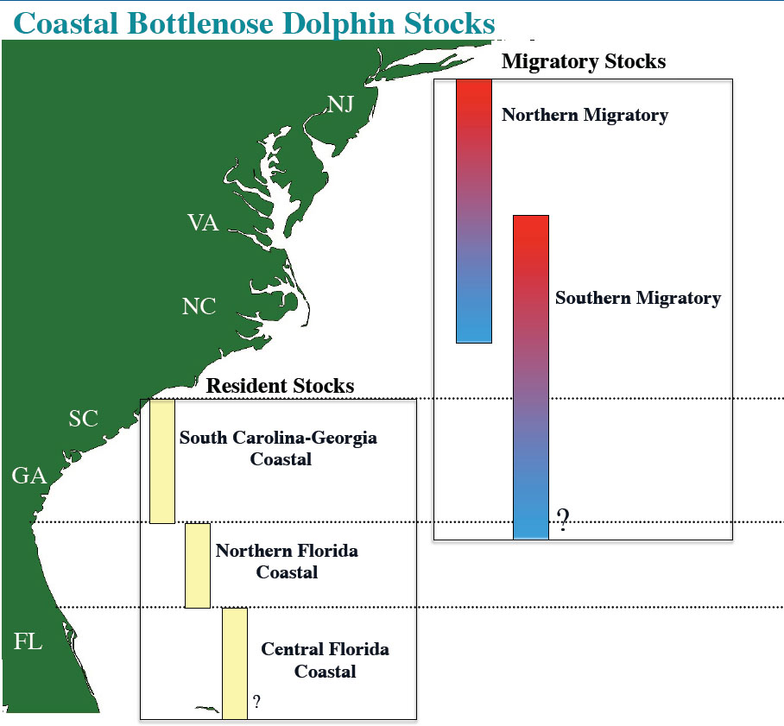

From NOAA.gov

Think about how a virus in general can spread through a population of organisms. Watch this animation for an example of the influenza virus in humans: <http://www.edudemic.com/this-is-how-a-virus-spreads-must-see-animation/>

Now consider how a virus might spread through a dolphin population. Learn more about dolphins through this website: <http://www.dolphins-world.com/>

1. How long do dolphins live?
2. Would dolphins have immunity to this virus?

Humans receive vaccines for many viruses like smallpox and measles. Using your computer and the Internet, research how a vaccine works. Use this website to get you started: <http://www.immunizationinfo.org/parents/why-immunize/how-vaccines-work> Answer the questions below based on your research. Please put your answers in your own words. Copying directly from a website is considered plagiarism.

1. What substances from the immune system naturally fight against a virus?
2. How does a vaccine work?
3. List two different ways vaccines can be created.
4. Based on your research, do you think vaccination a possibility for cetacean morbillivirus? Discuss the practicality of vaccinating a mobile, wild population.

Data and information from <http://www.nmfs.noaa.gov/pr/health/mmume/midatldolphins2013.html> and Susan Barco, Virginia Aquarium Stranding Response Team

**Licenses and Attribution**

**CC licensed content**

*Biology 102 Labs*. Authored by: Lynette Hauser. Provided by: Tidewater Community College. Located at: http://www.tcc.edu/. License: CC BY: Attribution