**Homeostasis**

**Learning Objectives**

1. Describe the anatomy of the liver including the path of blood flow from the intestines, through the liver, and to the heart
2. Compare glucose levels in different veins and arteries before and after eating
3. Describe the anatomy of the kidneys and a nephron including circulation of the blood
4. Explain the three steps of urine formation and where each stem occurs in the nephron
5. Predict whether substances will be found in the filtrate or the urine after kidney function
6. Explain how the kidneys and the liver contribute to homeostasis

Homeostasis describes the dynamic balance of the body’s internal environment and the effort to maintain a constant, stable inside. There are many body components that contribute to homeostasis. This lab activity will focus on the liver and the kidneys.

**Part I: Liver**

The liver is an organ within the digestive system and is responsible for maintaining sugar levels in the blood as part of homeostasis. After a large meal, the liver converts extra glucose into **glycogen**, a polysaccharide that stores glucose. A hormone called **insulin** is produced by the pancreas stimulates glycogen production. When levels of glucose in the blood drop, the liver breaks down glycogen back into glucose for the blood to circulate throughout the body. A hormone called **glucagon** produced by the pancreas stimulates this process. All cells of the body require glucose for cellular respiration to make energy.

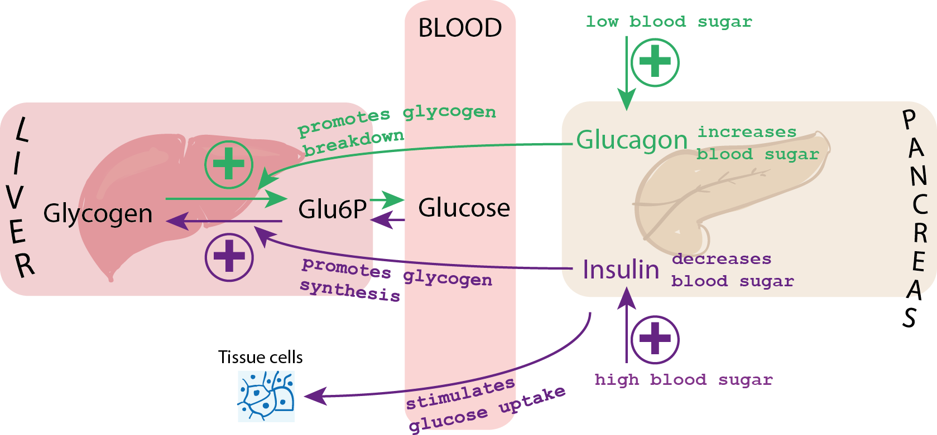

The liver receives blood from the small intestines through the **hepatic portal vein**. After a large meal, the hepatic vein would transport glucose rich blood from the small intestines to the liver. Blood leaves the liver and returns to the heart through the **hepatic vein**. We will conduct a simulation to learn more about the liver’s role in maintaining blood glucose levels in relationship to homeostasis.

The table below describes the blood serums you will test:

|  |  |
| --- | --- |
| Serum | Location |
| A | Mesenteric artery (takes blood from aorta to small intestine) |
| B | Hepatic portal vein (transports blood between intestines and liver) |
| C | Hepatic vein (takes blood form liver to heart) |

We will use a test called the **Benedict’s test** to determine the amount of glucose in each location. The benedicts test ranges in color from blue (no glucose) to orange/red (lots of glucose). Follow the directions below.

**Procedure**

Glucose levels after eating:

1. Fill the large beaker ½ full with tap water. Place the beaker on top of the hot plate. Turn the hot plate on to create a hot water bath.
2. Label three test tubes A1, B1, and C1 with a wax pencil
3. Use the small plastic ruler to mark on the test tube at 1 cm and 2 cm.
4. Fill test tube A1 to the 1 cm mark with serum A1 and to the 2 cm mark with Benedict’s reagent.
5. Fill test tube B1 to the 1 cm mark with serum B1 and to the 2 cm mark with Benedict’s reagent.
6. Fill test tube C1 to the 1 cm mark with serum C1 and to the 2 cm mark with Benedict’s reagent.
7. Place all three test tubes into the hot water bath at the same time.
8. Heat the tubes for 5 minutes. Observe and record any color changes.
9. Record your results in the table below. Remember that blue indicates no glucose and red/organge indicates the most glucose. A green color signifies some glucose.

**Results**

|  |  |
| --- | --- |
| **Table 1: Glucose levels after eating** | |
| Test tubes in order of color change | Source of the serum |
|  |  |
|  |  |
|  |  |

Which blood vessel, the mesentery artery, the hepatic portal vein, or the hepatic vein contains the most glucose after eating?

Explain why the hepatic portal vein contains more glucose than the hepatic vein after eating.

**Procedure**

Glucose levels before eating:

1. Keep your hot water bath from the first procedure
2. Label three test tubes A2, B2, and C2 with a wax pencil
3. Use the small plastic ruler to mark on the test tube at 1 cm and 2 cm.
4. Fill test tube A2 to the 1 cm mark with serum A2 and to the 2 cm mark with Benedict’s reagent.
5. Fill test tube B2 to the 1 cm mark with serum B2 and to the 2 cm mark with Benedict’s reagent.
6. Fill test tube C2 to the 1 cm mark with serum C2 and to the 2 cm mark with Benedict’s reagent.
7. Place all three test tubes into the hot water bath at the same time.
8. Heat the tubes for 5 minutes. Observe and record any color changes.
9. Record your results in the table below. Remember that blue indicates no glucose and red/organge indicates the most glucose. A green color signifies some glucose.

**Results**

|  |  |
| --- | --- |
| **Table 2: Glucose levels before eating** | |
| Test tubes in order of color change | Source of the serum |
|  |  |
|  |  |
|  |  |

Which blood vessel, the mesentery artery, the hepatic portal vein, or the hepatic vein contains the most glucose before eating?

Explain why the hepatic portal vein contains less glucose than the hepatic vein before eating.

Once you have recorded your results, please clean up the materials. Make sure to:

* Turn off and unplug the hot water bath
* Dump the contents of the test tubes down the sink
* Wash out the test tubes and place them in the test tube rack to dry

**Part 2: Kidneys**

The kidneys are part of the urinary system. As they produce urine to release nitrogenous wastes from the body the kidneys also maintain homeostasis through pH balance and water-salt balance in **osmoregulation**. These bean shaped organs are located along the dorsal wall of the abdominal cavity.

Observe the kidney models available in the lab. Locate the outer renal cortex tissue and the more internal renal medulla. The renal pelvis is the area that collects the urine. Find the renal artery and the renal vein.

The functioning unit of the kidney is called the **nephron.** Part of the nephron is located in the cortex and part in the medulla. Use the picture below and the models in the lab to identify the following components of the nephron.

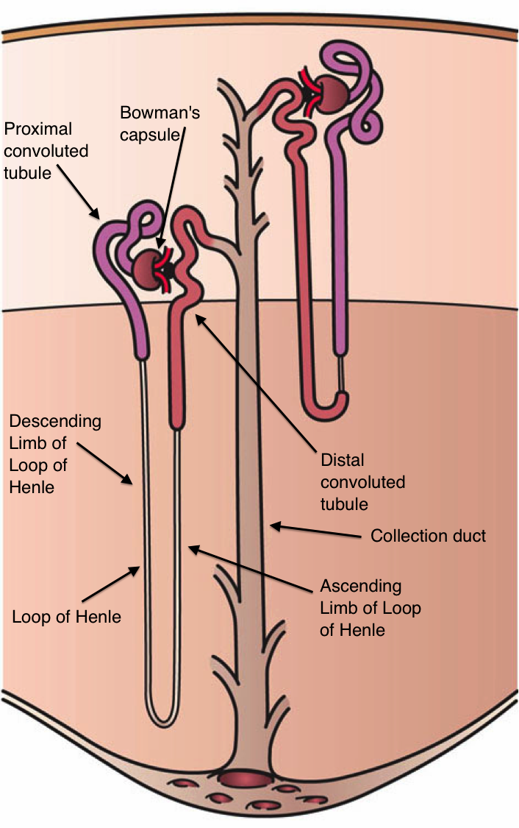

* Glomerulus
* Bowman’s capsule
* Proximal tubule
* Distal tubule
* Loop of Henle (descending limb and ascending limb)
* Collecting duct
* Peritubular capillaries

Which parts of the nephron are located in the renal cortex?

Which components of the nephron are located in the medulla?

Urine production in the kidney involves four main steps:

1. **Filtration**: molecules move out of the glomerulus into Bowman’s capsule. Large molecules like proteins and blood cells are too big to be filtered and remain in the blood.
2. **Reabsorption**: glucose and amino acids move from the proximal tubule back into the blood stream through peritubular capillaries.
3. **Secretion**: Substances like histamines, H+, and ammonia get secreted into the nephron from the peritubular capillaries
4. **Water reabsorption**: both the Loop of Henle and the collecting duct reabsorb water to maintain the blood volume

Label the parts of the nephron on the diagram to the right and indicate where the different urine production steps occur.

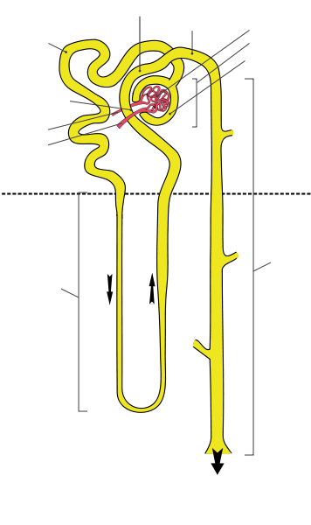

**Focus on Filtration**

Blood entering the glomerulus contains cells, proteins, glucose, amino acids, salts, urea, and water. Fill in the table below indicating which molecules will leave the glomerulus and enter the Bowman’s capsule. Write yes or no for each and state why based on size (small or big)

|  |  |  |
| --- | --- | --- |
| Substance | Enter Bowman’s Capsule? | Why? |
| Cells |  |  |
| Proteins |  |  |
| Glucose |  |  |
| Amino acids |  |  |
| Salts |  |  |
| Urea |  |  |
| Water |  |  |

**Focus on Reabsorption**

When the filtrate enters the proximal tubule it contains the following molecules: glucose, water, urea, amino acids, and salts. Water and salts are passively reabsorbed to maintain blood volume and pH as part of homeostasis.

What would happen to the blood volume over time if water were not reabsorbed?

How would this lack of water reabsorption affect blood pressure?

Fill in the table below indicating which molecules will be reabsorbed into the blood.

|  |  |  |
| --- | --- | --- |
| Substance | Reabsorbed? | Why? |
| Glucose |  |  |
| Amino acids |  |  |
| Salts |  |  |
| Urea |  |  |
| Water |  |  |

Kidneys are also important in **osmoregulation**, maintaing an internal salt/water balance. The kidney can produce large amounts of dilute urine or small amounts of concentrated urine depending on the needs of the body. The pituitary glad produces antidiuretic hormone (ADH) which controls the concentration of urine output. ADH specifically acts on the collecting duct making it more or less permeable to water.

The table below has several different events that would impact osmoregulation. Fill in the chart with either “increase” or “decrease” to explain how the kidney would help maintain homeostasis.

|  |  |  |  |  |
| --- | --- | --- | --- | --- |
| Event | Change in blood concentration | ADH output | Water Reabsorption | Type of Urine produced |
| Dehydration due to sunbathing in the afternoon and forgetting your water bottle |  |  |  | Scant, concentrated |
| Drinking large amounts of water throughout the day |  |  |  | Copious, dilute |
| Going to the move theater and eating a large bucket of salty popcorn without water to wash it down |  |  |  | Scant, concentrated |

Kidneys also play a role in pH balance.

If the blood is more basic than normal, what pH do you think the urine will be?

If the blood is more acidic than normal, what pH do you think the urine will be?

**Licenses and Attribution**

**CC licensed content**

*Biology 102 Labs*. Authored by: Lynette Hauser. Provided by: Tidewater Community College. Located at: http://www.tcc.edu/. License: CC BY: Attribution