**Microbiology and Protista Lab**

**Learning Objectives**

* Describe the basic structures of a bacterial cell.
* Name the three bacterial cell shapes and recognize each under the microscope
* Recognize and identify the cyanobacteria specimens viewed in the lab
* Recognize and identify the protista specimens viewed in lab
* Identify protista as photosynthetic or heterotrophic

**Part 1: Prokaryotes**

**Procedure**

1. Access the page “Reading: Prokaryotes.”
2. We will not be using any live bacteria specimens. Instead, watch this Youtube video about aseptic technique. <https://www.youtube.com/watch?v=bRadiLXkqoU> This technique is important to avoid microorganism contamination.

**Questions**

1. Answer the questions below based on the video.
   1. What two tools are most commonly used to transfer bacteria?
   2. With the Bunsen burner, what color is the hottest flame?
   3. How are the inoculation tools sterilized?
   4. When transferring bacteria from a liquid culture to a Petri plate, why do you turn the plate while spreading the bacteria?
   5. When transferring bacteria from a Petri plate to a stab culture, how many times should you stab the needle?
   6. When transferring bacteria into a liquid tube do you flame the mouth of the tube before inoculation, after inoculation, or both?
2. Skip to the end of the lab activity where it says “Prepared slides of typical bacteria” and view the prepared slides of bacterial shapes available in the laboratory.
3. Draw a picture of the coccus shaped bacteria.
4. Draw a picture of the bacillus shaped bacteria.
5. Draw a picture of the spirillum shaped bacteria.
6. View the prepared slides of cyanobacteria available in the laboratory. Although they are single celled note how they form colonies and attach to one another
7. What is the function of the heterocycst in the *Anabaena*?
8. If the *Oscillatoria* is moving, describe the movement quality below.
9. Which cyanobacteria species form chains? Which cyanobacteria species form clumps?

**Part 2: Protista**

**Procedure**

1. Access the page “Reading: Protists.”

**Questions**

1. View the Euglenozoans specimens available.
2. What color is the euglena?
3. What structure does the euglena use to move?
4. Can you see any internal chloroplasts?
5. Can you see the red eyespot? It does not give the organism vision, rather allows it to sense the presence of light.
6. *Trypanosoma sp*. cause African sleeping sickness. Learn more about this disease through this video: <https://www.youtube.com/watch?v=4aVUrGO97Zg>
7. What part of the human body does the *Trypanosoma* invade?
8. What structure does the *Trypanosoma* use to move?
9. How does the *Trypanosoma* avoid being killed by the white blood cells?
10. Can African sleeping sickness cause death?
11. View the diatom specimens available.
12. What material is found in the cell wall of the diatoms?
13. Are the organisms single or multi cellular?
14. View the brown algae specimens available.
15. What pigment does brown algae use for photosynthesis?
16. Name and describe the characteristics of one brown algae specimen below.
17. View the dinoflagellate specimens available.
18. What structure does the dinoflagellate use for movement? How many of these structures does it have?
19. Are the organisms single or multi cellular?
20. View the ciliate specimens available.
21. What structure does *Paramecium* use to move? Does it have only one or many of these structures?
22. *Paramecium* contains two nucli, a macronucleus (large) and a micronucleus (small). Can you find both of them on your specimen?
23. *Paramecium* also contains contractile vacuoles that help maintain water balance through osmosis. Can you locate any on your specimen?
24. View the red algae specimens available.
25. What pigment does red algae use for photosynthesis?
26. Name and describe the characteristics of one red algae specimen below.
27. View the green algae specimens available.
28. What pigment does green algae use for photosynthesis?
29. Name and describe the characteristics of one green algae specimen below.

## View the Tubulinid specimens available.

## What structure does *Amoeba* use to move?

## 

## Is the *Amoeba* single or multi celled?

## The *Amoeba* contains contractile vacuoles that help maintain water balance through osmosis. Can you locate any on your specimen?

**Summary Questions**

Answer the questions below to summarize the lab activity:

1. What type of cell is considered more primitive or basic?
2. State one difference between a prokaryotic and a eukaryotic cell.
3. What two domains contain prokaryotic celled organisms?
4. Identify structures 1, 3, 4, 5, 6, 7, 8, and 9 on the generalized prokaryotic cell pictured below

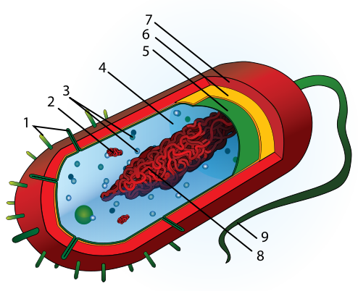

1. Are the cyanobacteria autotrophic or heterotrophic?
2. Which cyanobacteria species secretes a gelatinous sheath?
3. Which protista are most similar to green plants? Why?
4. You viewed several protista that exhibited movement. Give an example of a protista that used each of the following movement structures:
   1. Flagella:
   2. Cilia:
   3. Pseudopod:
5. Give two examples of photosynthetic protista you viewed in lab and state what pigment each uses for photosynthesis.

**Licenses and Attribution**

**CC licensed content**

*Biology 102 Labs*. Authored by: Lynette Hauser. Provided by: Tidewater Community College. Located at: http://www.tcc.edu/. License: CC BY: Attribution

*Prokaryotes Lab (Biology 102)*. Authored by: Michael J. Gregory, Ph.D.. Located at: <https://b51ab7d9e5e1e7063dcb70cee5c33cf7f4b7bad8.googledrive.com/host/0Bx6hk6AUBHxDc2d4TDJZTFIyMGs/default.htm>. License: CC BY-NC-SA: Attribution-NonCommercial-ShareAlike